SMART DISPLAY MODULE
SPECIFICATION

1.3 Inch Smart Knob Display with Wi-Fi /BLE
Model: | UEDX24240013-MD50E
Version: | V3.0
Date: | 2024-07-30

Customer Confirmation 客户确认
Approved by | Notes

REVISION HISTORY
Revision | Date | Contents of Revision Change | Remark
V1.0 | 20221223 | Preliminary release
V2.0 | 20240218 | Change to English version
V3.0 | 20240730 | Add schemata, GitHub project links, and environment configuration links

TABLE of CONTENTS

1. Introduction 4
1.1 Features 4
1.2 Appearance picture 5
2. Product information 6
2.1 Interface Description 6
2.2 Display Information 6
2.3 Voltage & Current 7
2.4 Reliability Test 7
2.5 Related software 7
3. MECHANICAL DRAWING 8
4. Schematic 9
5. Related downloads 10
5.1 Arduino relevant information 10
5.2 IDF relevant information 10

1. Introduction

1.1 Features
Brief Info:
- Outline Dimension:φ50 Round
- Interaction Method: Rotate and Press
- Shell Color: Black/White/Silver/Customized
- Power: DC 5V, 100mA

System
- OS: RTOS
- CPU: ESP32-C3 160Mhz
- RAM: 400KB
- Flash: 4MB
- Interface: UART/USB
- Support 2.4GHz Wi-Fi、BLE 5、BLE Mesh

Display
- Size: 1.3 Inch
- Resolution: 240*240
- Mode: IPS
- Brightness: 300 cd/m²
- Touch: without

Other
- Operation Temperature：-20~70℃
- Storage Temperature：-30~80℃

1.2 Appearance picture
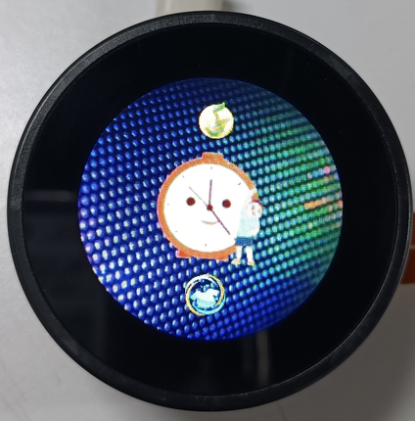

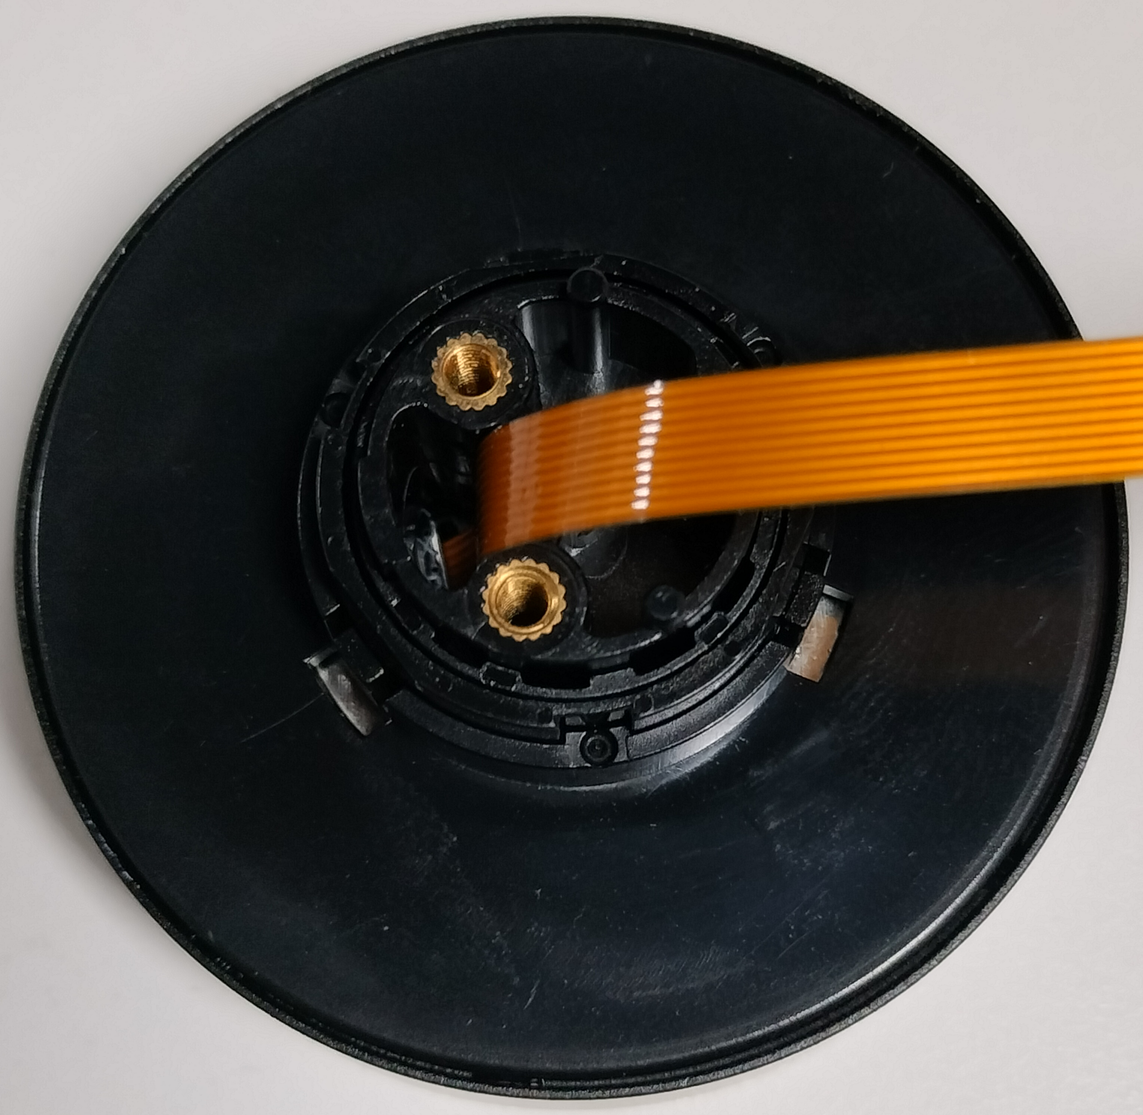

Product information

2.1 Interface Description
Pin NO. | Symbol | Description | Voltage Range | Remarks
1 | VCC | Power 5V | 5V
2 | ADC | GPIO3, ADC IO | 0-3.3V
3 | GND | Grounds | 0V
4 | NC | NC | -
5 | NC | NC | -
6 | RX | UART Receive | 0-3.3V
7 | TX | UART Transmit | 0-3.3V
8 | RST | Reset signal,  do not connect if not in use | 0-3.3V
9 | D+ | USB D+ | 3.3V
10 | D- | USB D- | 3.3V
The connector specifications is 10PIN 0.5mm pitch

2.2 Display Information
Item | Parameter | Description
Color | 65K colors | R5G6B5 16bits
AA | 32.40(W)*32.40(H) | 1.3 inch
Resolution | 240*240 | Round
Backlight | LED | 30000Hour Min
Brightness | 300 cd/m²

2.3 Voltage & Current
Item | Conditions | Min | Typ | Max | Unit
Power Voltage | DC | 4. 0 | 5.0 | 5.5 | V
Operation Current | VCC= +5V, Maximum backlight current | 50 | 100 | 150 | mA
Operation Current | VCC= +5V,backlight off | - | 50 | - | mA
Recommended power supply:5V 1A DC

2.4 Reliability Test
Item | Conditions | Min | Typ | Max | Unit
Working Temperature | 60%RH at 5V voltage | -20 | 25 | 70 | C
Storage Temperature | --- | -30 | 25 | 85 | C
Working Humidity | 25°C | 10% | 60% | 90% | RH
ESD | --- | Contact: ±4KV  Air: ±8KV |  |  | KV

2.5 Related software
Software name | Version | Software associated configuration | Development environment configuration link
Arduino IDE | 2.0.17  (esp32) | - Board: ESP32C3 Dev Module  - CPU Frequency: 160MHz (WiFì)  - Flash Frequency: 80MHz  - Flash Mode: QIO 80MHz  - Flash Size: 4MB (32Mb)  - Partition Scheme: Default 4MB with spiffs (1.2MB APP/1.5MB SPIFFS)  - PSRAM:NO  - Programmer: Esptool | ESP32-Arduino config (github.com)
ESP-IDF | 5.1.1  5.2.2 | Once configured, no configuration is required  （If you have any problem with the configuration, please contact us, we will help you） | ESP-IDF config (github.com)

3. MECHANICAL DRAWING
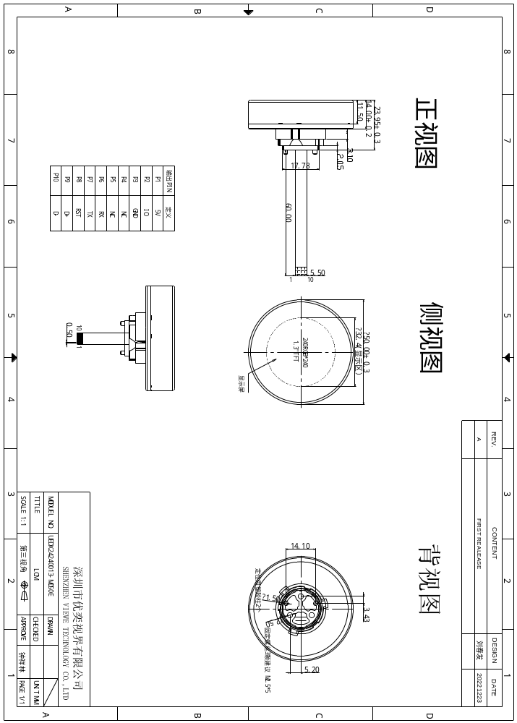

4. Schematic
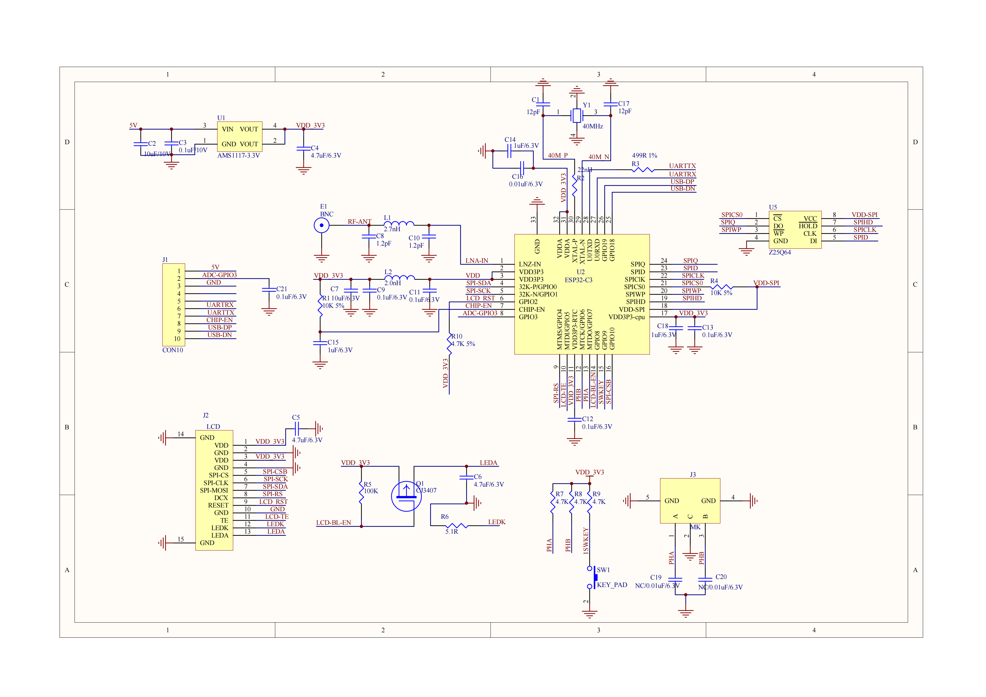

5. Related downloads

5.1 Arduino relevant information
ESP32-Arduino/examples/UEDX24240013-MD50E-Arduino-SDK at main · VIEWESMART/ESP32-Arduino (github.com)

5.2 IDF relevant information
ESP32-IDF/examples/UEDX24240013-MD50E-SDK-en at main · VIEWESMART/ESP32-IDF (github.com)

